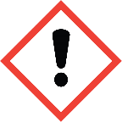
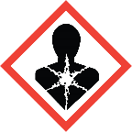
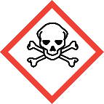
Toxic Chemicals
Standard Operating Procedures

General summary
Chemicals classified as toxic can cause potentially severe health issues. Exposure can occur through several different routes, so care must be taken to limit all types of exposure. Check the Safety Data Sheet to see which type of exposures are associated with the toxicity of the chemical in question, keeping in mind that toxicity increases as the hazard category decreases and that toxic chemicals may also have other hazards along with toxicity.
“Harmful”
Acutely Toxic Category 4
Acutely Toxic Category 1
More Hazardous
“Fatal”

Routes of exposure
Less Hazardous
Inhalation | Ingestion | Skin Contact
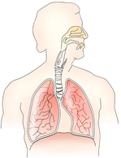  Breathing in dusts, powders, or vapors. | Consuming a chemical, items contaminated with a chemical, or using contaminated hands. | 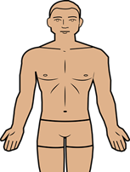  Splashes on intact and non-intact skin, in eyes and nose, or injection.

Planning considerations
- Use a less hazardous chemical, if possible.
- Purchase the minimum quantity and concentration needed.
- Purchase chemicals already in solution, if possible.

Engineering controls
Chemical Fume hoods are required when working with highly toxic chemicals. If a chemical fume hood is not available, glove boxes or other appropriate containment devices may be used.
Check that your fume hood is in working order by:
- Verifying the date on the certification sticker is in the past year
- Check the flow monitor is between 80 and 120 FPM
- Test the hood alarm to ensure correct function
- Contact EHS&EM if hood is not functioning properly.
Work safely in a fume hood by:
- Working with the sash as low as practicable and not above 16”
- Work 6 inches into the depth of the cabinet, not right on the edge
- Keep bulky equipment outside the hood if possible.

Administrative Controls
- Design procedures to:
Always Use Good Lab Safety Practices!

- No Food or drink
- Label fridges and ice machines “Lab Use only”
- Don’t work alone.
  - Minimize contact
  - Minimize exposure time
  - Minimize open container work.
- Designate and label work areas with limited access.
- Never leave experiments unattended.
- Practice proper glove removal technique. (Click here for a video).
- Never reuse disposable gloves.
- Wash hands before breaks and after work has been completed.
- Regularly check containers for cracks/warping.

Safe weighing practices
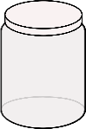
To weigh toxic powders safely, use a balance inside a chemical fume hood. If the balance can’t be placed in the fume hood, use the tared container procedure:
- Tare a container and lid.
- Add chemical to container in the fume hood.
- Close lid and weigh in the balance.
- Repeat until desired weight is achieved.

Personal Protective Equipment
Leave contaminated PPE in the work area and don’t use it to touch common items (e.g. doorknobs).
Hands | Eye & Face | Skin
- Disposable gloves required.  - Always check glove compatibility with the specific chemical in use.  - If working with a chemical with high dermal toxicity, double-glove.  - Change gloves when contaminated or damaged.  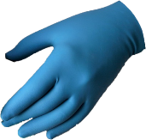 | - Safety glasses required.  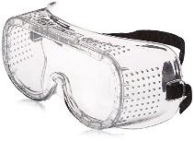  - If working with large amounts of liquid, safety goggles or face shield required. | 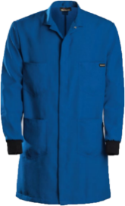  - Lab coat, fastened with sleeves extending to the wrists required. Keep street clothes covered.  - Long pants and close-toed shoes required.  - Consider Tyvek sleeves if working with large volumes.

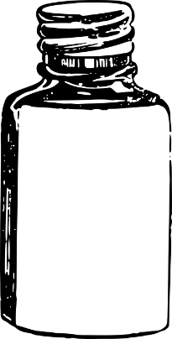
Labeling requirements
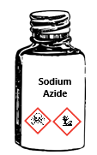
Chemical containers must be labeled with:
- Full chemical name and hazards
N₃Na

Sodium Azide

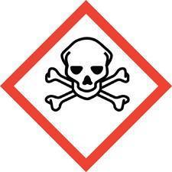
Sodium Azide

Toxic!
- Labels should be legible and in good condition.
- Regularly check chemical stock to verify chemicals are labeled properly.

Storage requirements
- Store in shatter-resistant containers in secondary containment.
- Keep containers tightly closed.
- Store in a well-ventilated area.
- Do not store with incompatible chemicals. Ex. Bleach + Vinegar = Chlorine gas

waste disposal
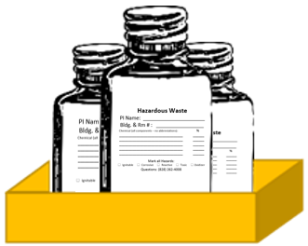
- Do not dispose of toxic chemicals down a sink drain.
- Keep containers capped tightly and use secondary containment.
- Separate waste by hazard class and compatibility.
- Label with an Appalachian state hazardous waste label (found here) prior to pick up.
- Waste should be neutralized before pickup, if possible.
Contact EHS & EM at (828) 262-4008 for chemical waste collection or regulatory guidance.

Emergency Information:
Fire:
Evacuate the building immediately, pulling the fire alarm on the way out. Meet at your building’s assembly point and contact emergency personnel (University Police- 828-262-8000 or 911). Follow instructions and advise emergency personnel of the situation. When able, contact the primary and secondary emergency contacts listed in the Lab Safety Plan.
Spills:
Do not clean the spill unless trained. Evacuate the area if the spill is fuming or irritating to the respiratory tract or eyes/skin. Contact emergency personnel (University Police- 828-262-8000 or 911). Follow instructions and provide information such as location, chemical name & hazards, amount released, etc. When able, contact the primary and secondary emergency contacts listed in the Lab Safety Plan.
Exposure:
Consult the Lab-Specific procedures to identify and follow any exposure procedures for the specific chemical in question. If no specific procedures are listed, for spills on the body, in the eye, or in an open wound, find and activate the nearest emergency shower or eyewash station. Immediately discard any contaminated clothing. Stand in the emergency shower stream or use the eyewash/drench hose to stream water over the affected areas for at least 15 full minutes. Contact emergency personnel (University Police- 828-262-8000 or 911) using the Safety Data Sheet of the chemical to communicate the hazards with medical professionals. When able, contact the primary and secondary emergency contacts listed in the Lab Safety Plan.

emergency contact information
Appalachian Police Department .………………………………….……………………………………. (828) 262-8000
Environmental Health, Safety, and Emergency Management ……………………………… (828) 262-4008
Watauga Medical Center ……………………………………………………………………………………. (828) 262-4100
Poison Control Center ………………………………………………………………………………………… (800) 222-1222

lab-specific procedures
Chemical Name: | Enter full chemical name here.
Hazards: | Describe all hazard classes and categories associated with this chemical (E.g. Carcinogen, Category 2).
Special First-aid Considerations: | Describe special first-aid treatments associated with this chemical including the location of supplies in the lab.
Maximum Purchased Amount: | What is the maximum amount the lab will purchase?
Maximum Purchased Concentration: | What is the maximum concentration the lab will purchase?
Maximum Use Concentration: | What is the maximum concentration allowed for use in the lab?
Chemical Storage Area: | Describe where the chemical is stored.
Required PPE: | Eye Protection: Safety glasses  Chemical splash goggles  Face shield  Hand Protection: Gloves (Specify Type)  (See Glove Compatibility Chart, check with your glove manufacturer)  Double Glove Required  Skin Protection: Lab Coat (Buttoned, Sleeves Extending to the wrist)  Tyvek Sleeves  Apron
PPE Storage Location: | Describe where PPE is stored.
Details of Process: | Enter process details for this chemical. How is it used? What is the purpose?
Designated Work Area(s): | Specify designated work area(s) for this chemical.
Work Area Decontamination Procedures: | Describe decontamination procedures.
Chemical-specific Waste Procedures: | Describe container type, storage location, and any chemical compatibility considerations.

