Enter Chemical Name
Standard Operating Procedures

General summary
Click here to enter summary information about this chemical. What are the hazards associated with this chemical? What is it typically used for? Does the Safety Data Sheet contain any important information pertaining to your procedures?

Routes of exposure
Which routes of exposure are the most applicable to this chemical?
- Inhalation: breathing in powders, gases, vapors.
- Ingestion: Consuming a chemical, contaminated items, or using contaminated hands.
- Skin contact: Splashes on intact and non-intact skin, in eyes and nose, or injection.

Planning considerations
What should lab members consider before working with this chemical?
  - Are less hazardous alternatives available?
  - Is there a smaller quantity or concentration that can be purchased?
  - If this is a powder, can it be purchased already in solution?

Engineering controls
Engineering controls eliminate, isolate, and reduce exposure to physical and chemical hazards by making physical changes to a space. This can include specialized ventilation, shielding, de-energizing locks, and more. Engineering controls should always be used before considering administrative controls or personal protective equipment. What engineering controls are applicable to work with this chemical?
If a chemical fume hood will be used, are there specific hoods that are designated for this chemical? Has the hood been certified in the past year? Is the flow between 80 and 120 FPM? Is the hood full of bulky equipment that could potentially affect air flow?

Administrative Controls

- Design procedures to:
Always Use Good Lab Safety Practices!

- No Food or drink
- Label fridges and ice machines “Lab Use only”
- Don’t work alone.
  - Minimize contact
  - Minimize exposure time
  - Minimize open container work.
- Designate and label work areas with limited access.
- Never leave experiments unattended.
- Practice proper glove removal technique. (Click here for a video).
- Never reuse disposable gloves.
- Wash hands before breaks and after work has been completed.
- Regularly check containers for cracks/warping.

Note the administrative controls that should be used when handling this chemical here.

Special First-aid Considerations: | Describe special first-aid treatments associated with this chemical including the location of supplies in the lab.
Maximum Purchased Amount: | What is the maximum amount the lab will purchase?
Maximum Purchased Concentration: | What is the maximum concentration the lab will purchase?
Maximum Use Concentration: | What is the maximum concentration allowed for use in the lab?
Designated Work Area(s): | Specify designated work area(s) for this chemical.
Work Area Decontamination Procedures: | Describe decontamination procedures.

Safe weighing practices
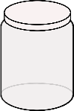
To weigh powders safely, use a balance inside a chemical fume hood. If the balance can’t be placed in the fume hood, use the tared container procedure:
- Tare a container and lid.
- Add chemical to container in the fume hood.
- Close lid and weigh in the balance.
- Repeat until desired weight is achieved.

Personal Protective Equipment
Leave contaminated PPE in the work area and don’t use it to touch common items (e.g. doorknobs).
Hands | Eye & Face | Skin
What type of PPE is required to protect your hands when using this chemical? Add or delete the following as applicable.  Disposable gloves required.  Always check glove compatibility with the specific chemical in use.  If working with a chemical with high dermal toxicity, double-glove.  Change gloves when contaminated or damaged. | What type of PPE is required to protect your eyes and face when using this chemical? Add or delete the following as applicable.  Safety glasses required.  If working with large amounts of liquid, safety goggles or face shield required. | What type of PPE is required to protect your skin when using this chemical? Add or delete the following as applicable.  Lab coat, fastened with sleeves extending to the wrists required. Keep street clothes covered.  Long pants and close-toed shoes required.  Consider Tyvek sleeves if working with large volumes.
PPE Storage Location: | Describe where PPE is stored.

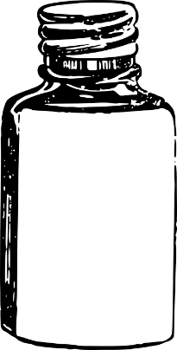
Labeling requirements
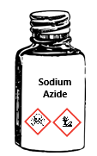
Chemical containers must be labeled with:
- Full chemical name and hazards
N₃Na

Sodium Azide

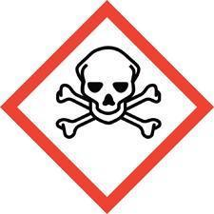
Sodium Azide

Toxic!
- Labels should be legible and in good condition.
- Regularly check chemical stock to verify chemicals are labeled properly.

Storage requirements
- Store in shatter-resistant containers in secondary containment.
- Keep containers tightly closed.
- Store in a well-ventilated area.
- Do not store with incompatible chemicals. Ex. Bleach + Vinegar = Chlorine gas

Note any special storage requirements for this chemical here.

waste disposal
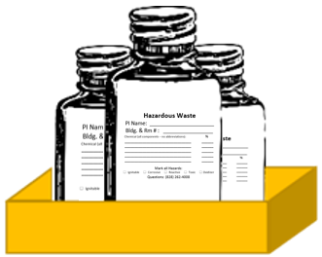
- Do not dispose of toxic chemicals down a sink drain.
- Keep containers capped tightly and use secondary containment.
- Separate waste by hazard class and compatibility.
- Label with an Appalachian state hazardous waste label (found here) prior to pick up.

Chemical-specific Waste Procedures: | Describe container type, storage location, and any chemical compatibility considerations.
- Waste should be neutralized before pickup, if possible.
Contact EHS & EM at (828) 262-4008 for chemical waste collection or regulatory guidance.

Emergency Information:
Fire:
Evacuate the building immediately, pulling the fire alarm on the way out. Meet at your building’s assembly point and contact emergency personnel (University Police- 828-262-8000 or 911). Follow instructions and advise emergency personnel of the situation. When able, contact the primary and secondary emergency contacts listed in the Lab Safety Plan.
Spills:
Do not clean the spill unless trained. Evacuate the area if the spill is fuming or irritating to the respiratory tract or eyes/skin. Contact emergency personnel (University Police- 828-262-8000 or 911). Follow instructions and provide information such as location, chemical name & hazards, amount released, etc. When able, contact the primary and secondary emergency contacts listed in the Lab Safety Plan.
Exposure:
Consult the Lab-Specific procedures to identify and follow any exposure procedures for the specific chemical in question. If no specific procedures are listed, for spills on the body, in the eye, or in an open wound, find and activate the nearest emergency shower or eyewash station. Immediately discard any contaminated clothing. Stand in the emergency shower stream or use the eyewash/drench hose to stream water over the affected areas for at least 15 full minutes. Contact emergency personnel (University Police- 828-262-8000 or 911) using the Safety Data Sheet of the chemical to communicate the hazards with medical professionals. When able, contact the primary and secondary emergency contacts listed in the Lab Safety Plan.

emergency contact information
Appalachian Police Department .………………………………….……………………………………. (828) 262-8000
Environmental Health, Safety, and Emergency Management ……………………………… (828) 262-4008
Watauga Medical Center ……………………………………………………………………………………. (828) 262-4100
Poison Control Center ………………………………………………………………………………………… (800) 222-1222

