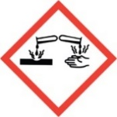
Corrosives
Standard Operating Procedures

General summary
Corrosive chemicals are substances that cause visible destruction or permanent changes to human tissue at the site of contact or are highly damaging to metals and stone. Corrosive chemicals can be liquids, solids, or gases and can affect the eyes, skin, and respiratory tract. The major classes of corrosives include acids, bases, and oxidizers. Liquid corrosive chemicals are those with a pH of 4.0 or lower (acids) or a pH of 9 or higher (bases). Some corrosive chemicals (e.g., hydrofluoric acid, nitric acid, and corrosive gases) have special handling or storage requirements and/or other hazards as well as corrosivity. Consult the Safety Data Sheet for the specific chemical you plan to utilize to create an agent specific SOP (see below).

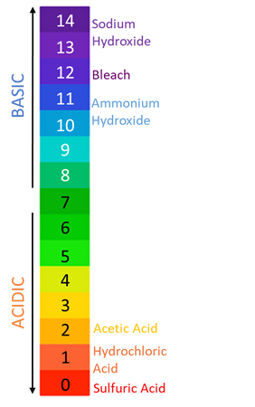
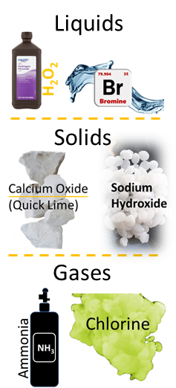

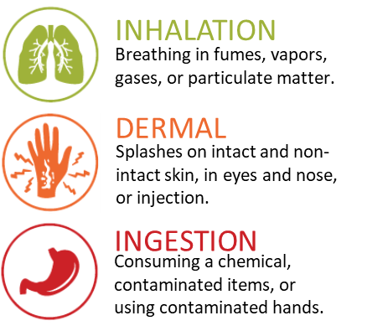
routes of exposure
- Damage from acids is generally felt immediately
- Damage from bases may not become painful for some time leading to more tissue destruction.
- The stronger, or more concentrated, the corrosive material and the longer it remains in contact with the body, the worse the injury will be.
- Corrosives that damage lung tissue may cause chemically induced pulmonary edema.

Planning considerations
- Use a less hazardous chemical, if possible.
- Purchase the minimum quantity and concentration needed.
- Ensure space is suitable for proposed work.
- Verify all work areas have appropriate engineering controls in place.

Engineering controls
Single pass ventilation, where 100% of the air is pulled from the outside and directly exhausted back out, should be provided to all areas where corrosives chemicals may be handled of stored.
Chemical Fume hoods are required when working with corrosive material. If a chemical fume hood is not available, glove boxes or other appropriate containment devices may be used.
Check that your fume hood is in working order by:
- Verifying the date on the certification sticker is in the past year.
- Check the flow monitor is between 80 and 120 FPM.
- Test the hood alarm to ensure correct function.
- Contact EHS&EM if hood is not functioning properly.
Work safely in a fume hood by:
- Working with the sash as low as practicable and not above 16.”
- Work 6 inches into the depth of the cabinet, not right on the edge.
- Keep bulky equipment outside the hood if possible.
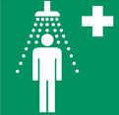
Emergency showers, eye washes, and/or eyewash/drench hose units must be available wherever there is a possibility of exposure to corrosive materials. An emergency shower/eyewash that provides a 15-minute flush of tepid water to the eyes and body must be located within 10 seconds (about 55 feet) of the corrosive work area. A weekly operational check of the eyewash stations is required and the path to all emergency equipment should be free of any obstructions.

Administrative Controls
- Design procedures to:
Always Use Good Lab Safety Practices!

- No Food or drink
- Wash Hands
- Clean after yourself
- Label fridges and ice machines “Lab Use only”
- Utilize appropriate PPE
- Never reuse disposable gloves
- Don’t work alone.
  - Minimize contact.
  - Minimize exposure time.
  - Minimize open container work.
- Designate and label work areas with limited access.
- Complete all relevant training.
- Know the location of all emergency equipment.
- Never leave experiments unattended.
- Do not pour water into acid. Slowly add acid to water while carefully stirring.
- Perform liquid transfers slowly using a funnel to minimize splash, splatter, and spills; for small volumes utilize luer-lock, integrated-needle syringes or mechanical pipettes.
- Ensure all containers/materials are compatible for proposed use.
- Minimize aerosol generating processes.
- Practice proper glove removal technique.

Personal Protective Equipment
Remove all PPE before leaving the lab; don’t touch common items (e.g., doorknobs) with gloves on.
Hands | Eye & Face | Skin
- Gloves are always required.  - Always check glove compatibility with the specific chemical in use.  - If working with a chemical with high dermal toxicity, double-glove.  - Change gloves when contaminated or damaged. | - Safety glasses required.  - Safety goggles and/or a face shield must be worn if there is a projectile hazard, when transferring large volumes, and in other situations where a splash or aerosols are likely (e.g., transfer of liquids outside of a fume hood).  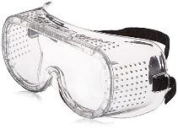 | - Lab coat, fastened with sleeves extending to the wrists is required.  - Long pants and close-toed shoes are required.  - Use a rubber apron when handling large volumes or there is a high splash risk.  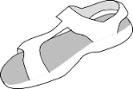

Labeling requirements
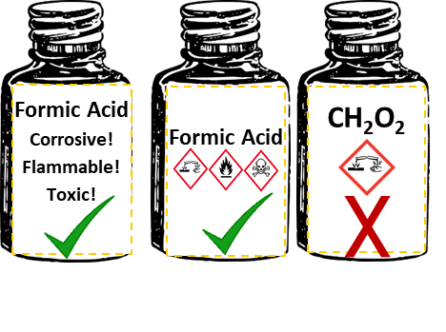
Chemical containers must be labeled with:
- Full chemical name and all hazards.
- Labels should be legible and in good condition.
- Regularly check chemical stock to verify chemicals are labeled properly.

Storage requirements
- Store in shatter-resistant containers in secondary containment.
- Store in a well-ventilated area.
- Store in corrosion-resistant cabinets whenever possible; If no corrosion-resistant cabinet is available, store in plastic containment in regular cabinets. Parafilming the cap can help reduce corrosion to the interiors of metal cabinetry/hardware. Flammable corrosives (e.g., acetic, and formic acid) should be stored within a flammable cabinet.
- Do not store corrosive liquids under sinks or above eye level.
- Keep containers tightly closed.
- Do not store with incompatible chemicals: Separate acids and bases; inorganic acids and organic acids. Access our compatibility flyer here!
- Regularly check containers for cracks/warping and expiration dates.

waste disposal
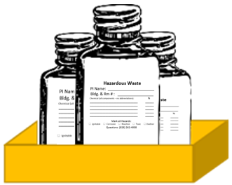
- Do not dispose of corrosives chemicals with a pH lower than 5 or higher than 11 in sinks or sewer drains.
- Store hazardous waste in chemically compatible containers within designated waste area.
- Ensure structural integrity of containers until pick up.
- Keep containers capped tightly and use secondary containment.
- Separate waste by hazard class and compatibility.
- Label with an Appalachian State hazardous waste label prior to pick up.
- Waste should be neutralized before pickup, if possible.

Contact EHS & EM at (828) 262-4008 for chemical waste collection or regulatory guidance.

Emergency Information:
Fire:
Evacuate the building immediately, pulling the fire alarm on the way out. Meet at your building’s assembly point and contact emergency personnel (University Police- 828-262-8000 or 911). Follow instructions and advise emergency personnel of the situation. When able, contact the primary and secondary emergency contacts listed in the Lab Safety Plan.
Spills:
Do not clean the spill unless trained. Evacuate the area if the spill is fuming or irritating to the respiratory tract or eyes/skin. Contact emergency personnel (University Police- 828-262-8000 or 911). Follow instructions and provide information such as location, chemical name & hazards, amount released, etc. When able, contact the primary and secondary emergency contacts listed in the Lab Safety Plan.
Exposure:
Consult the Lab-Specific procedures to identify and follow any exposure procedures for the specific chemical in question. If no specific procedures are listed, for spills on the body, in the eye, or in an open wound, find and activate the nearest emergency shower or eyewash station. Immediately discard any contaminated clothing. Stand in the emergency shower stream or use the eyewash/drench hose to stream water over the affected areas for at least 15 full minutes. Contact emergency personnel (University Police- 828-262-8000 or 911) using the Safety Data Sheet of the chemical to communicate the hazards with medical professionals. When able, contact the primary and secondary emergency contacts listed in the Lab Safety Plan.

emergency contact information
Appalachian Police Department.………………………………….……………………………………. (828) 262-8000
Environmental Health, Safety, and Emergency Management ……………………………… (828) 262-4008
Watauga Medical Center ……………………………………………………………………………………. (828) 262-4100
Poison Control Center ………………………………………………………………………………………… (800) 222-1222

lab-specific procedures
Chemical Name: | Enter full chemical name here.
Hazards: | Describe all hazard classes and categories associated with this chemical (E.g. Carcinogen, Category 2).
Special First-aid Considerations: | Describe special first-aid treatments associated with this chemical including the location of supplies in the lab.
Maximum Purchased Amount: | What is the maximum amount the lab will purchase?
Maximum Purchased Concentration: | What is the maximum concentration the lab will purchase?
Maximum Use Concentration: | What is the maximum concentration allowed for use in the lab?
Chemical Storage Area: | Describe where the chemical is stored.
Required PPE: | Eye Protection: Safety glasses  Chemical splash goggles  Face shield  Hand Protection: Gloves (Specify Type)  (See Glove Compatibility Chart, check with your glove manufacturer)  Double Glove Required  Skin Protection: Lab Coat (Buttoned, Sleeves Extending to the wrist)  Apron
PPE Storage Location: | Describe where PPE is stored.
Details of Process: | Enter process details for this chemical. How is it used? What is the purpose?
Designated Work Area(s): | Specify designated work area(s) for this chemical.
Work Area Decontamination Procedures: | Describe decontamination procedures.
Chemical-specific Waste Procedures: | Describe container type, storage location, and any chemical compatibility considerations.

