PI Name Lab Safety Plan

1. General Information

PI Name | Enter PI Name Here
PI Email | Enter PI Email Here
Building | Enter Building Name Here
Room #(s) | Enter Room Number(s) Here
Safety Contact Name | Enter Safety Contact Name Here
Safety Contact Email | Enter Safety Contact Email Here

2. Emergency Contact Information
Primary Contact | Name | Secondary Contact | Name
Position | Position Title | Position | Position Title
Business Hours # | Phone Number | Business Hours # | Phone Number
After Hours # | Phone Number | After Hours # | Phone Number
Emergency Evacuation Site | Enter Evacuation Meeting Site Here:

3. Emergency Equipment Locations
Emergency Exit(s) | Location
Emergency Alarm Pull Station | Location
Fire Extinguisher | Location
Fire Blanket | Location
AED Location | Location
Safety Shower | Location and Last Inspection Date
Safety Shower Records | Location
Eyewash Station | Location and Last Inspection Date
Eyewash Flusher | Name
Eyewash Station Records | Location
Chemical Spill Kit(s) Types | Type of Spill Kit(s)
Chemical Spill Kit(s) | Location

4. Emergency Procedures

Medical:
- On campus, call 911 or 828-262-8000. Off campus, call 911.
- Follow the instructions given by the emergency dispatcher.
- When you’re able, contact the primary and/or secondary emergency contact above.

JOB-Related Injury or illness
- In case of a life-threatening emergency, call 911 or 828-262-8000.
- Report all injuries or illnesses to your supervisor immediately.
- Students may seek appropriate medical attention from Student Health Services during clinic hours (Mon-Fri: 8:00 am – 4:00 pm; Sat-Sun: (Limited Services) 8:00 am – 11:00 am.)
- Seek appropriate medical attention from the following authorized primary care physicians:

Mon-Fri: 8:00 am - 8:00 pm
Sat-Sun: 8:00 am - 4:00 pm
Fast-Med Urgent Care
178 Hwy 105 Ext, Suite 101
Boone, NC 28607
828-265-7146
Non-Clinic Hours
Watauga Medical Center Emergency Department
336 Deerfield Road
Boone, NC 28607
828-262-4100

- If able to do so safely, employees should transport themselves for treatment. For non-emergency transportation to Fast-Med Urgent Care or Watauga Medical Center Emergency Room, contact University Police at 828-262-2150.
- Employees and students should:
  - Submit the Initial Notification of Incident Form as soon as possible.
- Supervisors should:
  - Ensure that the injured employee or lab member receives immediate and appropriate medical attention.
  - For employees, report the injury immediately to the Workers' Compensation Administrator, Carolyn Bosley (262-6488).

Chemical/Biological SpillS and Exposures
The range and quantity of hazardous substances in labs require preplanning to respond to spills and exposures. The cleanup of spills should only be executed by trained personnel. Spill kits with instructions, absorbents, reactants, and protective equipment should be available to clean up small spills. All solid or sharp objects should be removed utilizing tongs, dustpan and broom, or another mechanical device. A small spill is one that appropriately trained personnel is capable of handling safely without the assistance of safety and emergency personnel. All other spills are considered large and require outside assistance.
- Exposures
  - For spills on the body, in the eye, or in an open wound, find and activate the nearest emergency shower or eyewash station. Immediately discard any contaminated clothing. Stand in the emergency shower stream or use the eyewash/drench hose to stream water over the affected areas for at least 15 full minutes.
    - Seek medical attention immediately; clearly communicate to medical professionals the identity of the chemical or biological and the circumstances of the exposure.
    - On campus, dial 911 or 828-262-8000 to alert campus police and 828-262-4008 to alert EHS & EM.
    - When you’re able, contact the primary and/or secondary emergency contact listed above
    - To ensure adherence to NIH reporting requirements, the IBC must be notified if the exposure involved any recombinant nucleic acid material.
- Chemical Spills
  - Large spills (> 1 Liter or a material presents an immediate fire, safety, environmental, or health hazard regardless of quantity)
    - Attend to injured or contaminated persons and remove them from exposure - if you can do so without personal risk.
      - Escort injured or contaminated persons to an emergency eyewash station or emergency shower.
      - Instruct the person to remove contaminated clothing and shoes.
    - Alert people in the laboratory to evacuate
    - On campus, dial 911 or 828-262-8000. Off campus, dial 911.
    - Close doors and keep others away from the affected area.
    - If it can be done safely, block off any drains where the spill may enter.
    - Have a person knowledgeable of the incident and laboratory assist emergency personnel.
    - When you’re able, contact the primary and/or secondary emergency contact listed above.
  - Small spills (< 1 Liter, poses no immediate danger, and contained)
    - Alert people in immediate area of the spill.
    - Review chemical information from SDS.
    - Don appropriate protective equipment (safety goggles, gloves, a long-sleeved lab coat, etc.).
    - Confine the spill to a small area and prevent the spill from entering any drains.
    - Use the appropriate spill kit to neutralize and absorb the spilled material.
    - Collect the residue, place it in a container, label it, and dispose of it as chemical waste.
    - Clean the spill area with soap and water.
    - When you’re able, contact the primary and/or secondary emergency contact listed above.
- Biological Spills
  - Evacuate the space for 30 minutes to allow aerosols to settle.
  - Remove any contaminated clothing and PPE and discard as biohazardous waste.
  - Enter the lab space wearing appropriate PPE
  - Cover the spill with paper towels or other absorbent material to absorb the spill and prevent further aerosolization.
  - Pour 10% bleach on the spill starting out the outer edges and working inwards.
  - Allow paper towels soaked with disinfectant to stand for 20 minutes.
  - Clean up the bleach and spill using absorbent material.
  - Discard all spill clean-up materials as biohazardous waste.
  - Wash the affected surface with soap and water three times.
  - When you’re able, contact the primary and/or secondary emergency contact listed above,

Fire:
- Evacuate immediately, pulling a fire alarm pull station on your way out to active the fire alarm.
- Once you are safely out of the building, call 911 or 828-262-8000 to report a fire.
- Follow the instructions of emergency personnel and provide as much information as possible about the contents of your lab.
- When you are able, contact the primary and/or secondary emergency contact above.

Flood:
- For flooding in the lab, contact dial 911 or 828-262-8000 to alert campus police and 828-262-4008 to alert EHS & EM.
- Follow the instructions of emergency personnel and provide as much information as possible about the contents of your lab.
- When you’re able, contact the primary and/or secondary emergency contact above.

5. General Safety
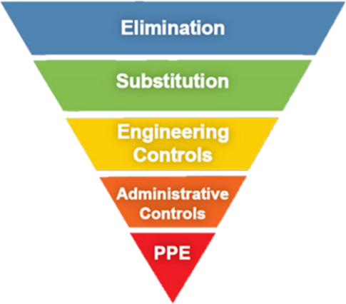
Labs should always use the hierarchy of controls to reduce employee exposure to hazards. Listed in order from most effective to least effective at minimizing risk, the hierarchy of controls consists of elimination, substitution, engineering controls, administrative controls, and personal protective equipment (PPE).

Food and drink
Food and drink Choose an item. allowed in this lab.
- Designated food/drink storage area: Enter Location.

Lab cleaning procedures
Laboratories should follow good general housekeeping procedures such as:
- Cleaning and decontaminating surfaces regularly and after any spills.
- Keeping all materials in their designated storage areas.
- Keeping surfaces free of unnecessary material and/or refuse.
- Keeping all walkways free of any slip or trip hazards.
- This lab stores the cleaning materials Enter Location

working alone procedures
Lab members Choose an item. work alone in this lab.
Working alone means working in the physical lab space when no other lab members are present who are aware of the hazards present in this lab.
- Working alone requires prior authorization by: Name
- Any lab members who plan to work alone must follow these procedures:
    - Do not perform any tasks for which you have not already received training.
    - Notify other members of the lab of your general plan for your time spent working alone.
    - Never perform any high-risk procedures or work with any chemicals that are considered highly hazardous when working alone.

lab security
Labs should always be locked when no lab members are present in the physical lab room(s).
Our lab is typically open: Enter Lab Business Hours
- Lab members are responsible for locking the lab when leaving if no other lab member is present, even if it’s just for 15 minutes!

6. Personal Protective Equipment
This lab Choose an item. personal protective equipment. (If you selected “does not require”, continue to the next section.)
Lab workers should take care to wear proper lab attire when entering a working lab. Proper lab attire should include long pants or skirts, closed toed shoes, and long hair tied back if there is a risk of hair contacting research materials. If working with chemicals and/or biological material, wear a lab coat with sleeves that extend to the wrist and appropriate gloves.
Fill out the table to below to indicate what PPE is required for work in this lab:
PPE Required | PPE Location | When PPE is Required | PPE Cleaning/Disposal procedure
Enter Text Here. | Enter Text Here. | Enter Text Here. | Enter Text Here.
Enter Text Here. | Enter Text Here. | Enter Text Here. | Enter Text Here.
Enter Text Here. | Enter Text Here. | Enter Text Here. | Enter Text Here.
Enter Text Here. | Enter Text Here. | Enter Text Here. | Enter Text Here.
Enter Text Here. | Enter Text Here. | Enter Text Here. | Enter Text Here.
Enter Text Here. | Enter Text Here. | Enter Text Here. | Enter Text Here.

7. Biological Safety
This lab Choose an item. with biological material. (If you selected “does not work”, continue to the next section.)

Biosafety level: Choose an item.
- For BSL2, the BSL2 Standard Operating Procedure is stored: Enter location of SOP

List of biological agents used in this lab: List Bio-agents Here

This lab Choose an item. with rDNA.
  - Location of IBC protocols (if applicable): Enter Location
  - Location of SOP (if applicable): Enter Location

Engineering Controls
- All labs working with biological material should have a sink for handwashing and an eyewash in the immediate area.
  - This lab’s handwashing sink is located: Enter sink location.
  - This lab’s eyewash station is located: Enter sink location.

- All surfaces should be able to be easily cleaned- no fabric surfaces.

- Any open manipulation or aerosol-generating procedures involving biological agents handled with BSL2 practices should be performed in a Class II Biosafety Cabinet (BSC).
  - Biosafety cabinet location(s): Enter Location
  - Last Re-certification Date: Click or tap to enter a date.
  - The re-certification date should be within the last year.
If a BSC is not available, full-face protection (safety glasses/surgical mask or face shield/surgical mask) must be worn in addition to a lab coat and gloves.
- Labs using centrifuges for processing biological material should ensure the following:
  - The centrifuge is on a sturdy, level surface with a balanced rotor.
  - The centrifuge lid is never opened while the rotor is moving.
  - For the manipulation of agents handled with BSL2 practices, covered centrifuge cups are used.

Admin Controls
- For work utilizing agents listed at BSL2, follow the BSL2 SOP.

- All lab members must be provided hands-on training by the PI or a senior lab member and complete the online general biosafety training provided by EHS & EM.

- A sign should be posted on the lab door specifying any PPE that should be worn before entering, emergency contact information, and a list of biological agents being used in the lab.
- No food, drink, handling contact lenses, or applying makeup is allowed in a lab that handles biological materials.

- Mouth pipetting is prohibited.

- Lab workers should wash their hands at the time of a glove change and before leaving the lab.

- Labs should work to minimize the use of glassware and sharps and to minimize the risks associated with splashes and aerosol generation.

- The lab is decontaminated regularly. Specify the lab’s decontamination schedule and procedure here.

Biological Waste
This lab Choose an item. biological waste. (If you selected “Does not produce”, move on to the next section.
Type of Waste | Autoclave* | Chemical Disinfection** | Vendor Pick-up***
Liquid
Solid
Contaminated Equipment/PPE
Sharps/Broken Glassware ****
Biological waste generally must be treated before disposal. If applicable, check the BSL2 SOP for waste treatment procedures. Otherwise, fill out the table to the right to indicate how this lab treats and disposes of biological waste.

* This lab uses an autoclave to treat biological waste:
- Autoclave location: Enter Location
- Autoclave Procedures: Enter Procedure Details
- Autoclave Safety:
  - Ensure proper autoclave training has been completed before use.
  - Refer to the following autoclave safety document: Direct Link for Download

** This lab uses chemical disinfection to treat biological waste:
- Chemical(s) used: Enter chemical(s) used.
- Disinfection procedures: Enter disinfection procedure
- Note that bleach (sodium hypochlorite) solutions become less effective over time. A fresh bleach solution should be prepared and dated at least weekly.

*** This lab contracts with a vendor to pick up biological waste:
- Vendor Name : Enter Vendor Name
- Pick-up Schedule: Enter Schedule Details

**** Sharps should be stored in a hard-walled container with a lid that is marked with the Biohazard symbol. Containers should be disposed of when they are 90% full. Never reach into a sharps or glassware container to adjust its contents.

8. Chemical Safety
This lab Choose an item. with Chemicals more hazardous than standard household cleaners. (If you selected “does not work”, continue to the next section.)
Labs should keep relevant Safety Data Sheets (SDS’s) on any chemicals they are using in the laboratory. Standard Operating Procedures (SOP’s) on the use of these chemicals and any emergencies that might occur are required based on the risk assessment below (Table 1) and should also be kept in the laboratory. A hard copy of these documents is preferred, but at minimum, lab personnel should be trained on the use of App Chem Inventory (contact EHS & EM for access 828-262-6838) and have access to an electronic version of all documents.
Based on the GHS Classifications in the SDS for a given chemical, Table 1 provides the required action. If a chemical requires a custom SOP, templates ready for customization can be found along with generic SOP’s provided by EHS & EM here: Lab Safety Documentation Page. If no SOP is required, labs must still handle the chemical safely as described in Prudent Practices in the Laboratory.
Table 1
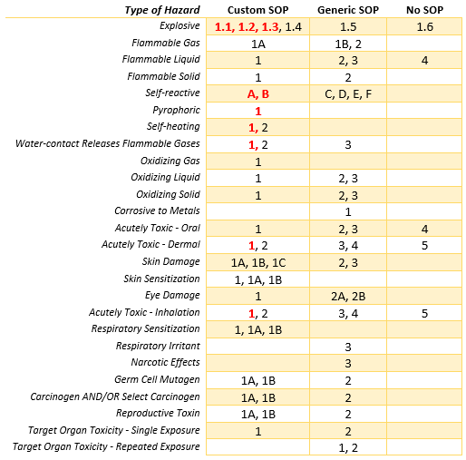
Location of SDSs: Enter Location
Location of Chemical SOPs: Enter Location
This lab works with (Check all that apply):

 | 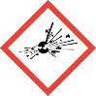 | Explosives |  |  | 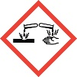 | Corrosives
 | 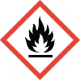 | Flammables |  |  | 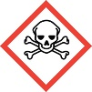 | Toxic Chemicals
 | 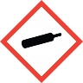 | Compressed Gases |  |  | 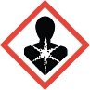 | Health Hazards
 | 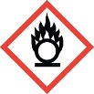 | Oxidizers |  |  | 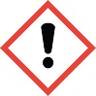 | Irritants
 |  |  |  |  | 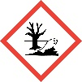 | Environmental Hazards

Chemical Storage Areas
Chemical storage areas should be kept clean and organized to minimize the risk of potentially dangerous chemical reactions. This involves ensuring chemicals are stored in appropriate containers, keeping these containers maintained and secure, and arranging them in chemically compatible groups (Direct Link for Download) to prevent unwanted interactions.

Chemical containers are in good condition (not cracked/warped):………….…...………………………Yes No
All chemical containers are closed:……………………………………………...…….................................... Yes No
Chemicals are labeled with their name and any associated hazards:…………………………………….Yes No
Secondary containment sufficient to contain a spill is being used:………………………………………..Yes No

Engineering Controls
- All labs working with hazardous chemicals should have a sink for handwashing, a safety shower, and an eyewash in the immediate area.
  - This lab’s handwashing sink is located: Enter sink location.
  - This lab’s safety shower is located: Enter safety shower location.
  - This lab’s eyewash station is located: Enter eyewash location.
- Chemical fume hoods should be used when indicated by an SOP, when working with an acutely toxic chemical, carcinogen, reproductive hazard, sensitizer, irritant, or when a flammable or explosive vapor may be created.
  - Chemical fume hoods should NOT be used as storage for chemicals or for large-bulky equipment; if this is unavoidable, raise the bulky item about 2 inches off the interior to allow air flow underneath and position the item so it is not blocking any baffles.
  - Always work with the sash as low as possible.
  - Always perform chemical work at least 6 inches into the interior depth of the hood.
  - Shut the Sash! when the hood is not in use to save energy.

Our lab uses a chemical fume hood:…………………………………………...…….…………………………………….Yes No
Location(s): Enter Location
Certification date(s): Click or tap to enter a date.
If certification is not within the past 12 months, call Facilities Operations (828-262-3190)
Sash type:………………………………………......……………………………………Vertical Horizontal Combination

Housekeeping:………………………………………………….....…………………………………………………………Free of clutter
…………………………………………………………………………………………………………………….….Free of bulky equipment
…………………………………………………………………………………………………………………….….Free of chemical storage

9. Chemical Waste
This lab Choose an item. chemical waste. (If you selected “does not generate”, continue to the next section.)
Chemical waste on campus is generally collected three times a year (April, August, and December). At the time of pickup, the university environmental affairs manager will contact each department to have labs prepare a Hazardous Waste Inventory Form. Labs are generally considered Satellite Accumulation Areas and are therefore subject to these rules:
- Satellite accumulation areas must be in the same room where the waste was generated and possess proper DOOR SIGNAGE.
- Containers must be in good condition, stored in secondary containment sufficient to contain and spill, labeled with the name of all contained chemicals with volume percentages, associated hazards, and “Hazardous Waste”.
  - If the manufacturer’s label is still present on the primary container, it must be defaced.
  - Approved labels are available for printing here.
- Each lab may accumulate up to, but not exceed 55 total gallons of hazardous waste or one quart of acute (p-listed) hazardous waste.
  - If these volume limits are exceeded, contact EHS & EM within 24 hours.
- Our lab’s waste accumulation area is: Enter Location:
Labs should try to minimize the amount of waste being generated by reusing or recovering chemicals, storing stock for future use or redistributing unwanted chemicals to a different user. Try to reuse or recover waste if possible.
Drain disposal of a chemical substance is limited. The town of Boone specifically prohibits drain disposal of chemicals which are:

- Fire Explosion hazard
- Solid or Viscous
- Particles > than 0.5 inch
- pH < 5.0 OR pH > 11.0
- Noxious liquids, gases or solids
- Water reactive
- Toxic
- Dyes that impart color
- Temperature >150° F (66° C)
- Radioactive materials
- Most oils
- Anything that could form toxic gas
- Ammonia, ammonia salts or chelators
- Hazardous Waste
- Able to cause excessive foam

For any chemical waste-related questions or issues, contact the EHS & EM ENVIRONMENTAL AFFAIRS MANAGER)

Radiological Waste Procedures
This lab Choose an item. Radiological waste. (If you selected “generates”, contact THE EHS & EM ENVIRONMENTAL AFFAIRS MANAGER)

10. Other Notes
This section is to take note of anything specific to this lab that may have not been covered in this document.
Enter Notes

11. Lab Sign
Customize and post the following door sign on the exterior doors of this lab.

Hazards |  | Lab Name
CHEMICAL | 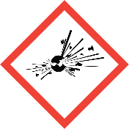
 |  | PI Name |  | Enter PI Name Here
 |  | PI Email |  | Enter PI Email Here
 | 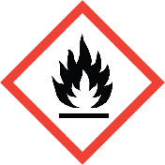 | Building |  | Enter Building Name Here
 |  | Room #(s) |  | Enter Room Number(s) Here
 |  | Safety Contact Name |  | Enter Safety Contact Name Here
 | 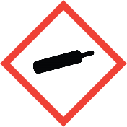 | Safety Contact Email |  | Enter Safety Contact Email Here
 | 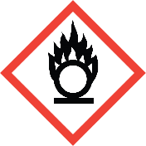 | PPE Required in this lab:
 | 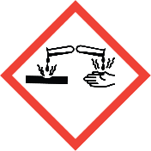 | Lab Coat  Long Pants  Close-toed Shoes |  |  | Gloves  Safety Glasses  Safety Goggles
 | 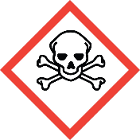
 | 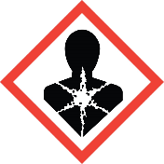 | Other Entry Requirements:
 | 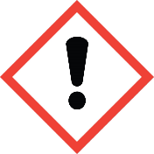 | Enter additional requirements for entry here.
 | 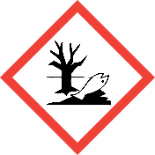
BIOLOGICAL | 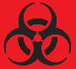  BSL1  BSL2 | Emergency Contact Information:
 |  | Primary Contact
 |  | Contact Name |  | Name
 |  | Business Hours # |  | Phone Number
 |  | After Hours # |  | Phone Number
 |  | Secondary Contact
RADIATION | 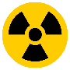
 |  | Contact Name |  | Name
 |  | Business Hours # |  | Phone Number
 |  | After Hours # |  | Phone Number
 |  | Emergency Evacuation Site
 |  | Enter Evacuation Meeting Site Here:

