Hazards |  | Lab Name
CHEMICAL | 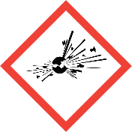
 |  | PI Name |  | Enter PI Name Here
 |  | PI Email |  | Enter PI Email Here
 | 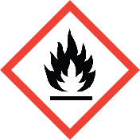 | Building |  | Enter Building Name Here
 |  | Room #(s) |  | Enter Room Number(s) Here
 |  | Safety Contact Name |  | Enter Safety Contact Name Here
 | 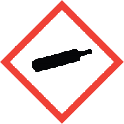 | Safety Contact Email |  | Enter Safety Contact Email Here
 | 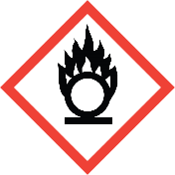 | PPE Required in this lab:
 | 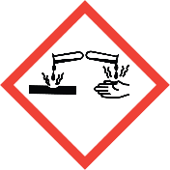 | Lab Coat  Long Pants  Close-toed Shoes |  |  | Gloves  Safety Glasses  Safety Goggles
 | 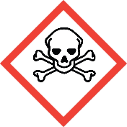
 | 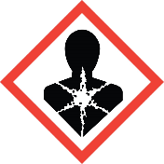 | Other Entry Requirements:
 | 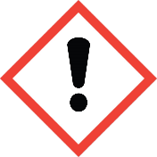 | Enter additional requirements for entry here.
 | 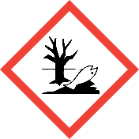
BIOLOGICAL | BSL1  BSL2 | Emergency Contact Information:
 |  | Primary Contact
 |  | Contact Name |  | Name
 |  | Business Hours # |  | Phone Number
 |  | After Hours # |  | Phone Number
 |  | Secondary Contact
RADIATION | 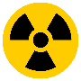
 |  | Contact Name |  | Name
 |  | Business Hours # |  | Phone Number
 |  | After Hours # |  | Phone Number
 |  | Emergency Evacuation Site
 |  | Enter Evacuation Meeting Site Here:

